How to Change a Password Using Outlook Web App (Exchange 2010)

  - Go to CASD’s Webmail (the link is updated on the District website found under Quick Links) at https://mail.chambersburg.k12.pa.us/owa.
  - You can use one of the 3 methods below to login with your username.
firstname.lastname (jane.smith)
firstname.lastname@chambersburg (jane.smith@chambersburg)
chambersburg\firstname.lastname (chambersburg\jane.smith)
Your password is your 8 digit birth date. For example: 07131969
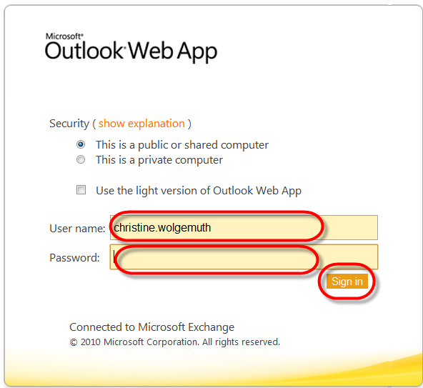
Click Sign in after entering your information.
  - Once you are logged in, click on Options, located at the top right hand corner of the OWA.
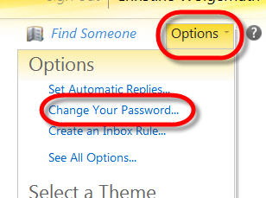

- Choose Change your Password…

- Enter your former password as well as your new password, and then click on Save. (Your former password is your birth date. For example: 02021980)
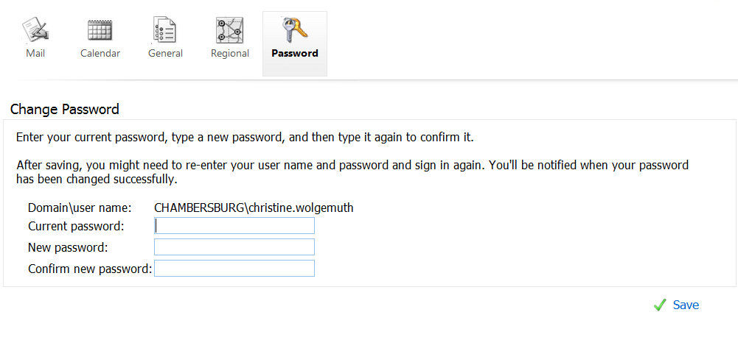

  - Outlook Web App will tell you that your password has been successfully changed. Click on OK to log in with your new password.
. 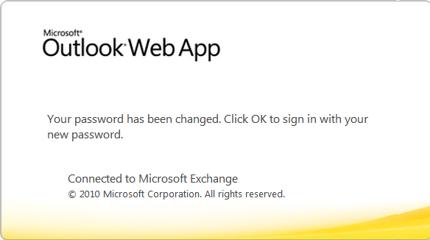
Note: At the time of writing this FAQ, the "OK button” only appeared in Microsoft Explorer. If you are using any other browser, just click an option on the page and you will be directly sent to the login page.

